Biggest Prepper Challenge
e-mail to biggestprepper@gmail.com
Week # 12 Name: Davis, Vicki Date: 4/30/ 2014 Weekly Points Total: 20
Week # 12 Date: April 26, 2014
Meal # 1: new skill – new tool – make tortilla Meal Points: 6
Recipe: Homemade Taco shells, sausage and beans Source: my own food storage recipe
Cooking method: grinder/flaker/vitamix and my stove Total Points: 2
- Bonus Points: Facebook: X Twitter Google plus Total Bonus points: 1
Recipe: making flour tortillas – 4-25 Total Meal points: 3
Using previously ground wheat flour and white flour (I used my hand grinder, but had to use my vitamix to make it useable flour) I used the Everyday Gourmet Book recipe for flour tortillas. I allowed the mixture to set for over 20 minutes, but it seemed to work ok. I made 10 balls, which next time I have noted in the cookbook – to make 12 to 15 smaller balls, as they turned out larger than my skillet. After I used my new wooden Tortilla Press, I still found it necessary to use the rolling pin to flatten them even more. And prior to cooking each tortilla, I tried to thin them out even more – by stretching the tortilla, which made them too large for the skillet. I cooked some thawed sausage from 12-2013 and rehydrated Thrive cheddar cheese for the topping. I opened a can of pinto beans and put some of the rehydrated cheddar cheese shreds on the top and heated them in the microwave. We did have some of our fresh yellow cherry tomatoes from our Aero Garden, growing on the kitchen counter on the side of our plates.
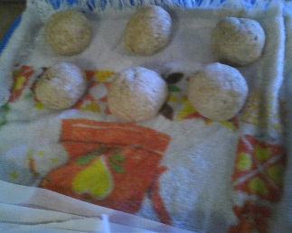
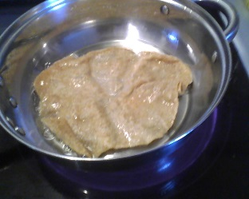
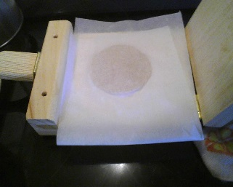
Source: my own food storage recipe
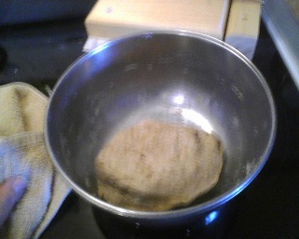
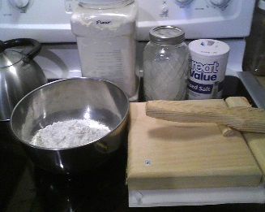
Ingredients (minus oil) mixed-need to rest made into 10 balls wooden tortilla press frying flour tortilla
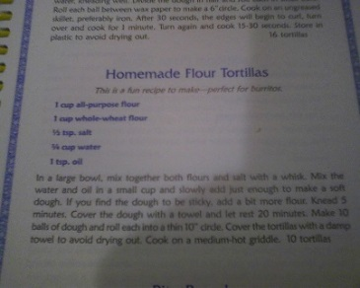
Ingredients: 1 cup of white (church flour) and wheat flour (previously ground) ½ tsp salt, ¾ cup of water and 1 TBSP oil.
I used the new cookbook I bought called Everyday Gourmet. This is the recipe.

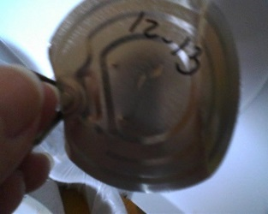
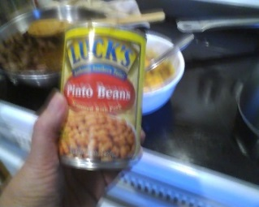
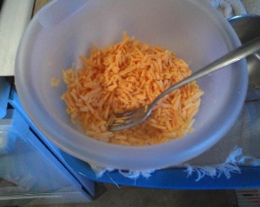
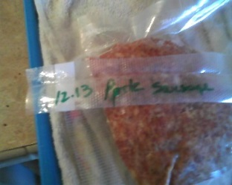
The final plated meal did not show up on my computer. It was pinto beans, and sausage tacos made with the fresh made tortillas and some fresh tomatoes from the Aero Garden.
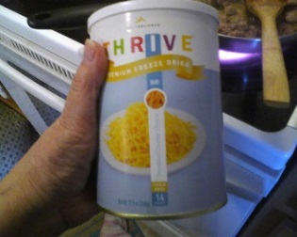
Thawed sausage thrive cheddar cheese cheese rehydrated 12-13 pinto beans lid from beans
Just an FYI -- I consider our Aero Garden a Food Storage Item that we use all the time not just in the winter. Usually by now we would have the garden vegetables growing in them, but since I have been ill and planning knee surgery this year, we will go without a large garden this year. We have purchased a City Planter (from home depot ($30.00) that we will have 2 tomato plants in and 1 bell pepper plant in. And Randy has made a holder 48” in height 2 x 4’s with a box built on the top to perfectly hold one 1-cubic foot bag of potting soil of which we have planted lettuce seeds (just planted seeds on Wednesday) that will sit outside our deck so we can have fresh lettuce. We also have a Tower Garden that was not growing inside this winter - year, but the plan is to have it growing outside this summer and inside this winter. We have purchased grow lights and plan to make out back room into a small “greenhouse- garden area” in the winter. We have one Meyer lemon, aloe and several plants that have survived through the winter. My lemon grass has survived along with some coleus plants and will go outside soon.
Meal # 2: new skill – new tool – make granola Meal Points : 6
Recipe: Granola Bars Source: my own food storage recipe
Cooking method: grinder/flaker/ Total Points: 2
- Bonus Points: Facebook: X Twitter Google plus Total Bonus points: 1
Recipe: Make granola bars– 4-28 Total Meal points: 3
Using previously purchased quinoa flakes and adding the home made oat groat flakes I made, the cracked Buckwheat, cracked wheat and white wheat, spelt flax seed and faro ~ filled quart jar ~ plus 2 cups oatmeal, and 2 cups of quinoa and other flakes and ¼ cup of millet uncooked. (only the oat groats would flake today – nothing else would flake for me) I blended the ingredients into a large bowl, added ¾ cup honey, ¼ coconut oil melted, ½ cup brown sugar, ½ cup organic coconut, pre-ground chia seeds, almonds, pumpkin seeds and raw sunflower seeds home dried cranberries and blueberries, ¼ cup pre popped amaranth and 2 TBSP dry vanilla. I put these into a large glass pan and just sat them on the counter to set up on their own. I plan to Seal-a-meal them – however they did not set up overnight – I tried drying this oven, but they still did not set up well, so I put mini chocolate chips on the top, set them in the oven to melt, and I am writing this now… Hopefully they will work into bars, or they will just become the best granola we have ever had!
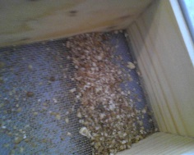
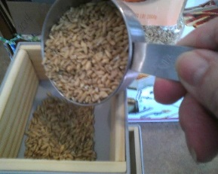
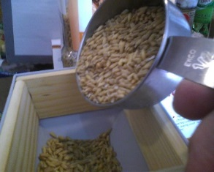
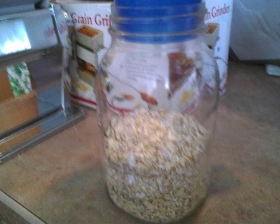
notice the silver grinder and box
this is Buckwheat that didn’t flake

½ cup Oat groats in grinder hooper 1 cup groats make this much oatmeal
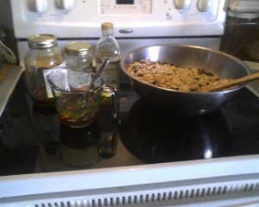
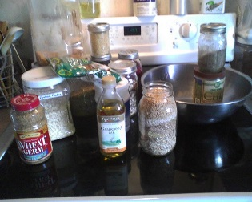
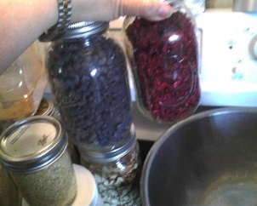
Granola Bar Ingredients Blueberries & cranberries Honey and oils Oils and bowl full North Georgia honey
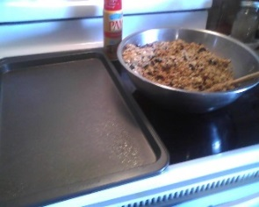
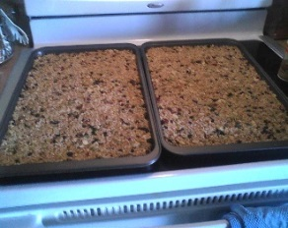
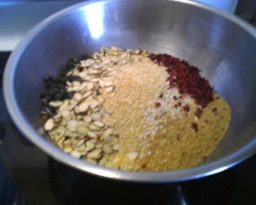
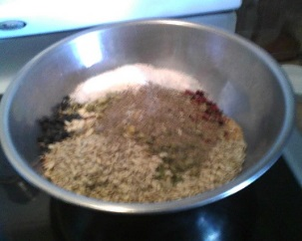

More ingredients and more ingredients mixed and ready put into pans

Meal # 3: new skill – new tool – make overnight oatmeal Meal Points : 8
Recipe: Overnight oatmeal Source: adapted from your recipe
Cooking method: non electric grinder/flaker and wonder oven Total Points: 4
- Bonus Points: Facebook: X Twitter Google plus Total Bonus points: 1
Recipe: making overnight oatmeal– 4-27 Total Meal points: 3
We are out of oatmeal and I need to do something without going downstairs to get a new can for about a week. So I thought I would get my small “oat maker” and a Thrive can of oat groats. I made a quart of oatmeal and I prepared it late last night for our overnight breakfast. Using the oat groats I ground into flakes, I used the ingredients list below. I boiled the water and honey and added home ground oat flakes dried apricot pieces and pecan pieces. I put it in the wonder box overnight, when I opened the lid it looked a bit watery, until I stirred it. The nut meats were on the top, where the apricot pieces were on the bottom. After it was stirred, it was put into bowls and eaten… delicious!
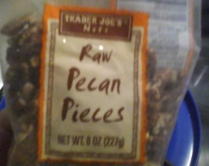
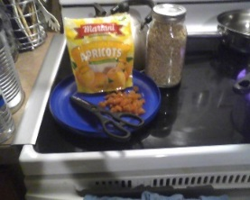
ground oat groats
and cut- apricots pecan pieces and local honey

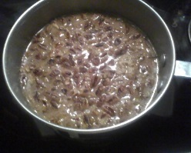
dark pic of wonder oven
1st opening of overnight pan
finisihed stirring bowl of breakfast

Recipe:
6 cups water (I used 6 cups of water + 2 TBSP honey)
2 cups home ground oat goats into flakes
1 cup freeze dried fruit
1/4 tsp. salt

Just a long note from here on out – mostly for me to remember and have to go back to when I need it…. Also for you…
Well, it wasn’t until this evening 4-29-2014, when I made the overnight oatmeal did I realize... honestly, we use our food storage daily... the can of spam for tonight’s diner was dated 4-2012... The can of green beans were dated 2-2011. The lettuce and tomatoes were from the store, but if we had the aero garden and tower garden growing all year (as planned through this year) it would be part of our Food Storage items. The can of tuna for lunch was dated 5-2012 the onions were church onions from 1999, the pickle relish was 11-2013 and the mayonnaise was dated 2-2013...
Last night’s dinner was a frozen pizza shell from 2-2014 and the pepperoni was frozen from 8-2013 the mozzarellas cheese has been in the freezer since 12-2013. And although I have Thrive cheeses, I try to have only have one can open of cheese open at a time. I made the flour tortillas using wheat flour I ground in December, and cooking oil dated 6-2013. Then I got to thinking, I dehydrated blueberries in 1996 and 1998 and have started using them within the last 3 years. The cranberries were dehydrated in 2012 and may be quite bitter. The Georgia Mountain Honey is from 2009 when we first moved here, but since we are such honey
lovers, we use many different kinds for different reasons... avocado honey for making bread, the sage honey is almost all in storage, as it won't sugar, I like orange blossom and mesquite honey on my toast and Randy likes buckwheat and the Australian honey that we got as a Christmas gift 3-4 years ago. We like light honeys like lavender and apple blossom for our teas, the local sumac and sourwood honey are so strong and almost bitter to us, but we still use them. The NE Georgia honeys go well with sweet fruit. Then I look in the cupboard and see the peanut butter is 2013, most of the Jell-O is almost all dated early 2013, used when I was sick for so long) whereas some noodles are dated 2009. I started food storage monthly purchase in 1989. Back then, my monthly was $25.00. I make and have homemade jams, and tomatoes, green beans, pork, pinto, garbanzo and kidney beans, pickles, salsa and chili starter. All home canned. Along with my own type of dinner in a jar, prior to finding the Dinner in the Jar book.
I have oils and chocolate chips and cacao chips, powder and organic coconut, spices, dried almost everything... I love dehydrating green onions to use in salads and cooking. Things like nuts and dehydrated fruits and vegetables... things like oranges (and lemons for my water and herbal teas) apple peels, figs and cranberries all dehydrated here at home. One time as I dehydrated onions (my husband put his helmet on the top –center hole) of my Garden Master Pro dehydrator, which was the main reason I found the Excalibur dehydrator – which I paid on - for monthly for over a year to purchase. I pressure can my beans and meats when they are on sale at the stores, or I get a FFA pig half. I can ham chunks after "Christmas" which is wonderful, although this year we had a large cut of beast instead that was almost completely consumed by the 22 of us... all in all it is amazing what food storage we do have and use... yes – noticing we use it daily.
What I need to remember - learn... is how to can strips of beef for stroganoff, to can cooked hamburger, so all that is needed is to open the can that goes with the Dinner in a Jar. I need to try to can butter...I have purchased shelf stable cream for our food storage meeting the 3rd week in May...and will make different butters for that class. I have a friend who canned ghee and I've asked her to help me this year can some. Speaking of canning, I have purchased several dozen Tattler Reusable Lids and I need to learn to use them. I want to make more canned meats and butter this year.
I do know that we eat about 48 pint jars of salsa in a year and 24 pints and 6 quarts of canned to tomatoes yearly. Pinto beans we use approx. 48 to 60 pints a year. All these things need to be refreshed in 2014. We consume 48 to 60 pints of green beans in a year also. My goal is trying not to consume purchased cans of green beans.
And all the fruit that seems to be in the freezer. I need to can them so I don’t have to depend on the freezer so much! From mango, raspberries blackberries and there is our hand-picked blueberries which we go through about 3 gallons a year. And that is an easy estimate.
So all in all – we use out food Storage on a daily basis. I usually do an inventory, however this year has been an odd one with my 80 year old mother wanting to move in with us, to whooping cough and now my knee surgery. It is a good thing we have our food Storage.
I want to tell you how much you have helped me figure out what I need to do with my food storage and all I have learned from this challenge you have started! What works for me verses what will not work trying to explain to someone else how to make it work? How difficult it is to try to give directions in a fully packed freezer – just where the frozen ground sausage verses the frozen ground hamburger is location wise. How to advise my family on what types of meat they may want to purchase if we go in on a FFA pig, or raise our own beef with the neighbor.
So many little things – like the pancakes or how many cans of Spam or Jell-O that we really do have in Storage, and that using them is the purpose of having them. Less trips to the Grocery store. By the way it has dwindled down to only one trip to the Grocery store a week, unless hubby wants/needs something we do not have. .
Thank you, again and again for all my lessons learned!
Vicki Davis

