Biggest Prepper Challenge
e-mail to biggestprepper@gmail.com
Week # 11 Name: Davis, Vicki Date: 4/22/ 2014 Weekly Points Total:
Week # 11 Date: April 19, 2014
Meal # 1: Purpose – just do something! Make breakfast Meal Points : 2
Recipe: pancakes with blueberries and walnuts and bacon Source: my own food storage recipe
Cooking method: my stove Total Points: 0
- Bonus Points: Facebook: X Twitter Google plus Total Bonus points: 1
Recipe: pancakes – 4-19 Total Meal points: 3
Using church pancake mix and ground chia seeds for my eggs. I grabbed a bag of blueberries from 7-13 from the freezer and broke pieces of frozen walnuts from at least a year ago. Using ground chia seeds (from a prior food storage challenge) I made the pancake mix. After the pan was hot I poured the batter in and allowed he batter to set enough to somewhat harden then added blueberries and walnut pieces to the top of the pancake. I also grabbed a package of pre-cooked bacon (also in my food storage) and baked it while the pancakes were cooking. (just a note – after I prepared this meal – I promptly fell asleep for 2 hours and found a very messy kitchen that was in need of attention) -
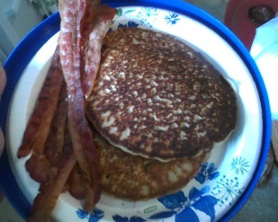
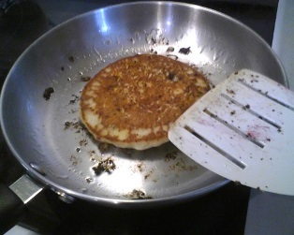
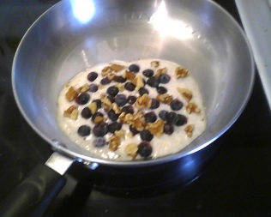
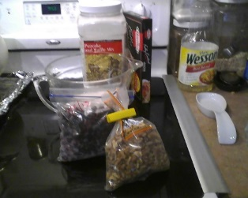
Source: my own food storage recipe
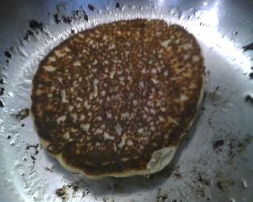
Ingredients: Church pancake mix, blueberries, walnuts and bacon picture of plated meal – notice the paper plate holder is a Frisbee - we found many years ago with several children wanting to take Frisbee’s to the beach it fits the 10 inch paper plate. Since then, our counter has a supply of paper plates and these blue Frisbees- ie paper plate holders.
My lessons learned on this exercise –
#1 – If it were a true emergency – I do have ground chia seeds and pancake mix. I would however think twice about opening the freezer only for blueberries and walnuts.
#2 – After being ill, I am realizing what we use more of and what we need more of. In the summer we have BLT’s often and having 6 boxes of the pre-cooked bacon is not enough if I plan to use them for breakfast. I have been waiting for a sale on the pre-cooked bacon to resupply and now found I have only 1 box in the food storage. Need to re-think our usage needs of this precooked bacon, or see if I can figure out how to make some in “jars”. I know I definitely need to rethink my home canning needs. To be able to utilize all the “Dinners in a Jar” meals, I need to have pre-cooked hamburger and somehow figure out how to can cooked pieces of sliced round steak for my stroganoff. The pork I’ve canned – both pieces and larger chunks work perfect for what I cook. And the canned Ham chunks work perfect for scalloped potatoes from a box or my “Dinner in a Jar” recipe or in a couple cans of green beans for an easy meal. However, I need to re- think the beef aspect. The canned hamburger never looked good enough to eat, so I need to learn to cook it first and then can it.
#3 – I want to learn to plan better - to use our food storage more and not depend so much on grocery store food.

Meal #2: skill + make oatmeal from oat groats Bonus Meal Points : 2
Skill : non-electric – use of a hand crank oatmeal making machine. Total Points: 2
Recipe: Easter Breakfast – Oatmeal with apricots Source: your overnight oatmeal recipe w/changes
Cooking method: cooking box cozy Total Points: 2
- Bonus Points: Facebook: X Twitter Google plus Total Bonus points: 1
Recipe: overnight oatmeal – with home dried apricots 4-19 Total Meal points: 7
We are out of oatmeal and I need to do something without going downstairs to get a new can for about a week. So I thought I would get my small “oat maker” and a Thrive can of oat groats. I will make the oatmeal tonight before I go to bed so we will have breakfast for Easter Sunday. I want to go to church for a short time today, and I wanted this Skill of making oatmeal from scratch to add to my points this week. Plus – I will make a quart, plus enough for the meal I will prepare tonight for our overnight Easter breakfast. Using your recipe to make overnight oatmeal in the Wonder Box, I added pieces home dried apricots and a bit of butter to the pan, eliminating the use of

This is the oatmeal maker
This is the oat groats
This is buckwheat groats – I choose to make some buckwheat groats to see if hubby likes these for breakfast.

