Cooking with a Wonder Oven
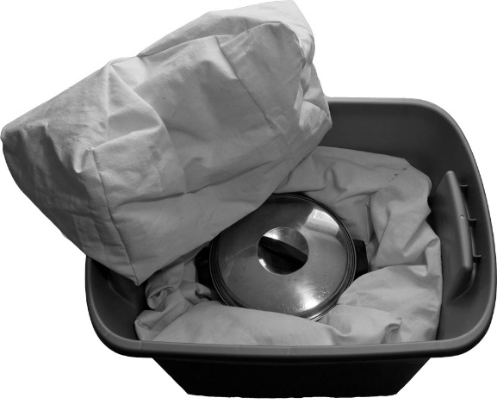
- Pillows are used inside an 18 or 20 gallon bin. The larger pillow is used on the bottom, the smaller one on top.

- Cook using thin metaled pots with tight fitting lids.

- Cook using the closest sized pot for the amount of food being cooked. Any extra air space decreases the efficiency of the insulation, so as much as possible use the most appropriately sized pot for the job. Smaller pots for smaller amounts.

- Always pre-heat the lid of the pot to be just as hot as the pot itself before beginning to cook. You’re creating a “mini-oven” for your food, so bringing the lid to temperature is just as important as the temperature of the food itself being hot, as well as the rest of the pot.

- Remember that while your Wonder Oven will keep boiling water at temperature for 11-18 hours, likewise it will keep frozen foods frozen for the same amount of time, as well as cold foods cold. This can be very useful in the event of fridge or freezer outages, long grocery shopping trips, picnics, etc. The key is always to keep the pillows nestled around the food (without many air pockets between food items) and no peeking!

- For recipes and step by step instructions and pictures, you can visit www.myfoodstoragecookbook.com. Go to the “categories” tab and select “Wonder Oven Cooking”.
Using your Wonder Oven you can:

- Bake bread
- Bake muffins
- Make yogurt
- Cook rice/grains
- Make stew
- Cook small cuts of meat
- Make “crock pot style” lasagna
- Make breakfast quiches
- Make homemade tamales
- Simmer sauces
- Make rice pudding
- Cook Steel Cut Oats
…And much more!

- Besides the recipes on the blog, the underlying idea is that once any food is heated entirely through, when transferred to the wonder oven, it will continue cooking/ remain hot for hours. Use for baked potatoes, baking for 30 minutes before wrapping in a foil emergency blanket (to retain heat while keeping the pillows clean) and continue cooking in the Wonder Oven for 45 minutes, or whenever you’re ready. Your food will never burn in the Wonder Oven.
Be creative and have fun!
Care and Washing Instructions:
Pillows can be washed on delicate cycle and dried normally in a dryer (for about 15 minutes). The can also be hung out to dry. Never put them away in the bin and shut the lid if still damp or they’ll mold. Very often in cooking, however, steam will escape lightly dampening the pillows. Unless severely damp, I’ve never had a problem with mold on the pillows after cooking. If cooking something that’ll likely make a mess, you can guard against this by using a foil emergency blanket to place the pot onto, wrapping it around the pot before adding the top pillow.

